**Process Map**

**Using for first time do**

1. Save the ExtractionToSQL folder at **C:\Temp**
2. Edit these fields in RunSQL.bat accordingly

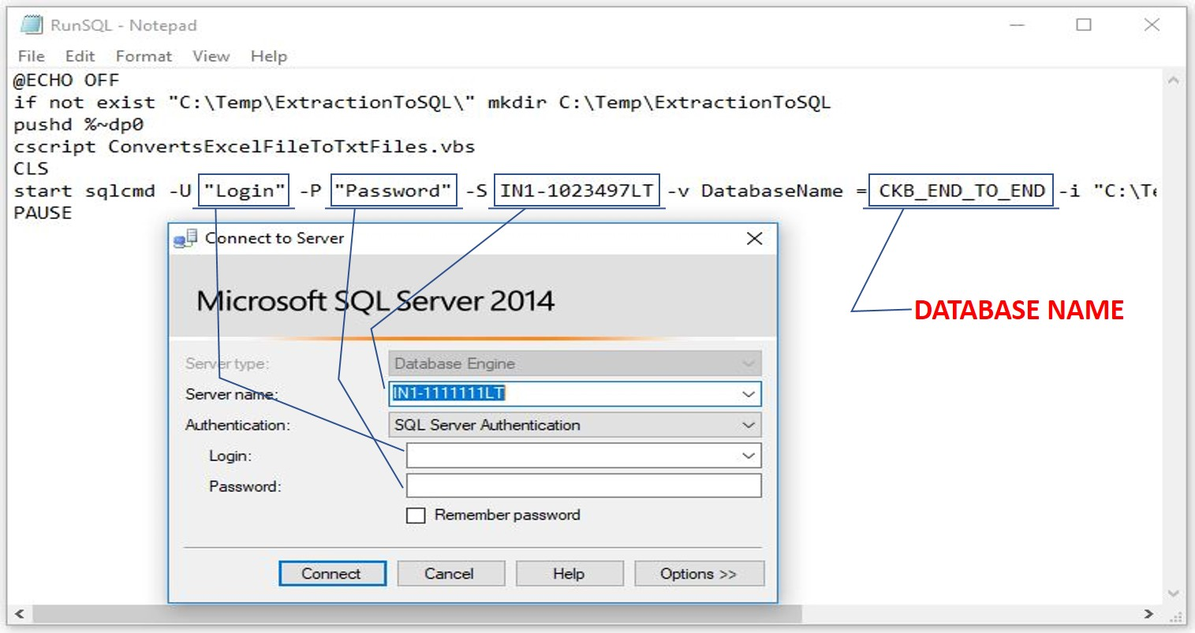

**Methodology of the Process**

1. Batch file first runs the VBScript and then the SQL Query.
2. VBScript lets you select the excel file to be extracted to SQL DB.
3. It copies the necessary columns from Performance sheet to Product sheet
4. It converts the file to tab delimited text files (.txt) viz., “Products Data” and “Store Data” and saves it to the specified file.
5. Batch file then runs the SQL Query.
6. SQL Query first takes in data to temp tables.
7. Then Updates the already existing data in the main DB according to the respective IDs if it doesn’t exist then Inserts it to it. Main DB are ix_spc_product and ix_str_store.

**Note**

1. The excel file should have 3 sheets in the respective order – Product Data, Performance Data and Store Data. Names of the sheet can be different.
2. The headers should be in the same order as the sample excel.
3. If folder of the SQL Query is changed, then change the path in Batch file accordingly.
4. The VBScript should be in the same folder as the Batch file
5. ConvertsExcelFileToTxtFiles.sql should be at “C:\Temp\ExtractionToSQL\”
6. Temp Data base tables are Temp_Product_Data1, Temp_Product_Data, Temp_Store_Data and Temp_Store_Data1
   1. Temp_Product_Data1 and Temp_Store_Data1 table’s all columns is of varchar(max). Used while Bulk Insert
   2. Temp_Product_Data and Temp_Store_Data table’s columns datatypes are of the ones in the final DB. Used for data type conversions.

**Files**

1. **VBSCript – ConvertsExcelFileToTxtFiles.vbs**
2. **SQL Query - Extracting_To_SQL.sql**
3. **Batch File – RunSQL.bat**